SESSION 8 — Gearhaven
Beat 2 — The Cogtooth Market (Fight 1)

Morning on Cogtooth Hill
Morning comes bright and loud in Gearhaven. After the best sleep you’ve had in days — and a quick breakfast of warm gear-shaped pastries pressed into your hands by Henna (“Can’t have you saving the world on an empty stomach!”) — you set off up the winding streets toward Cogtooth Hill, where the Artificer’s Guild waits.
The way up climbs through the Cogtooth Market, the busiest place you’ve ever seen. Stalls are stacked three high and bolted to the walls. A merchant sells umbrellas that open themselves. A baker’s tray of cookies marches past on tiny mechanical legs. Steam-trams clatter overhead, and the whole crowd moves to the rhythm of that giant heartbeat under the city. Boom. Boom. Boom.
And there, in the middle of it all, is a face you recognize — Pinion, the fidgety tram-conductor from last night. Except this morning she looks frazzled, her brass hands fluttering as she tries to wrangle a line of boxy little delivery-robots that keep bumping into things.
Pinion: “Oh! Oh, it’s you three! Steady gears, steady gears— forgive me, it’s been a MORNING. My delivery-servitors have gone all wobbly. They keep— no, not there— they keep dropping the— OH NO.”

The Machines Turn
One of the little servitors stops dead in the middle of the market. Its head swivels around with a grinding CLICK. The soft blue light behind its eyes flickers… sputters… and turns a hot, angry RED. Then the others do the same — and behind them, a hulking shape that had been hauling crates all morning straightens up to its full, towering height, a wooden crate still gripped in one massive claw. Sparks spit from every seam. Their cores crackle with blue lightning. And every one of them turns to face YOU.
Pinion: “That— that’s not supposed to happen! That’s the Cargo Hauler — it could flatten a wagon! Look OUT!”

The Cogtooth Market erupts — two Rogue Servitors and the towering Cargo Hauler turn on the crowd.
▶ Lilly’s moment (read this, or offer it to Lilly’s player). Lilly — your artificer instincts prickle. The way those machines seized up wasn’t normal. Make an Arcana or Investigation check, DC 12.
(On a success:) You catch it in a heartbeat — that wasn’t a broken gear or a loose wire. Something reached INTO them, a pulse of strange energy, there and gone, that flipped their little minds from “deliver crates” to “attack.” You don’t know what could do that… but you’d bet your best wrench it’s connected to that skipped heartbeat last night.
(On a fail:) You can tell it’s not normal — these machines didn’t just break, something flipped them — but it happens too fast to pin down. It’s going to bug you all day.

Stand and Fight — or Switch Them Off
As the machines lurch toward you, you notice something: behind the red glow, each servitor still has a little brass shut-off lever on its back, painted yellow — the kind every Gearhaven machine has for emergencies. You could fight these things the hard way… or a quick, brave hand could dart in and flip that switch to shut one down for good.
Two ways to win (say this plainly). They can ATTACK the machines — or get next to one and FLIP ITS SWITCH to shut it off (a check, no killing needed). The little servitors’ levers are easy to reach. The Cargo Hauler’s lever is mounted high on its back (15 ft up) — reaching it takes climbing, flying (Stabby’s sash!), or a flying summon. Reward the clever, mercy-minded play — these machines aren’t evil, just hijacked.
Difficulty: HARD. 2 Rogue Servitors + 1 Cargo Hauler. The Hauler can grab a hero and crush them, and the servitors’ death-sparks punish bunching up. Someone may drop — that’s intended. Full stats on the next page. The Hauler is VULNERABLE TO LIGHTNING (telegraph the crackling blue core) — Lilly’s and Ursa’s lightning shine, and it previews the boss’s weakness later.

Aftermath
The last machine sputters, its red glow fading back to a dim, sorry blue — then it slumps over with a sad little wind-down whine, like a music box running out of turns. The market goes quiet. Slowly, nervously, the crowd peeks back out from behind the stalls.
Pinion rushes over, hands fluttering.
Pinion: “Oh, you wonderful, brave little things! Are you hurt? I’ve never — in forty years I’ve never seen them do THAT! It’s been getting worse all week. Little wobbles, then big ones, and now… now this. The whole city’s frightened.”
She wrings her cap, then straightens with sudden purpose.
Pinion: “You said you’re for the Guild? Good. GOOD. If anyone can fix this, it’s Vane and his clever folk up the hill. Here — let me take you the rest of the way myself. It’s the least I can do. And honestly? I’d feel safer with you three beside me.”
Transition. Pinion escorts the party up to the Artificer’s Guild — straight into Beat 3. If Lilly succeeded on her check, she’s carrying a real clue (“something reached INTO them”) to raise with Vane.

End of Beat 2. Next: up the hill to the Artificer’s Guild, and a scatterbrained genius named Vane. (Enemy stats on the following page.)

ENEMIES — Fight 1: The Malfunctioning Machines
Cogtooth Market • Difficulty: Hard • 2× Rogue Servitor + 1× Cargo Hauler
ROGUE SERVITOR  Small construct • CR 2    AC 15 HP 39 (6d6+18) Speed 30 ft  STR 13 DEX 16 CON 16 INT 3 WIS 8 CHA 5  Resist poison; nonmagical B/P/S  Imm. (cond) charmed, frightened, poisoned, exhaustion  Senses darkvision 60 ft  Traits  Overclocked Death-Spark. At 0 HP, each creature within 10 ft makes a DC 13 Dex save or takes 7 (2d6) lightning.  Shutdown Switch. Action within 5 ft, DC 14 Arcana or Sleight of Hand, shuts it down instantly — no kill needed.  Actions  Multiattack. Two Flailing Slams.  Flailing Slam. +5 to hit, reach 5 ft. Hit: 8 (1d10+3) bludgeoning.  Spark Lash (Recharge 5–6). Ranged +5, 30 ft. Hit: 10 (3d6) lightning; target’s speed halved until end of its next turn. | CARGO HAULER  Large construct • CR 3 • centerpiece  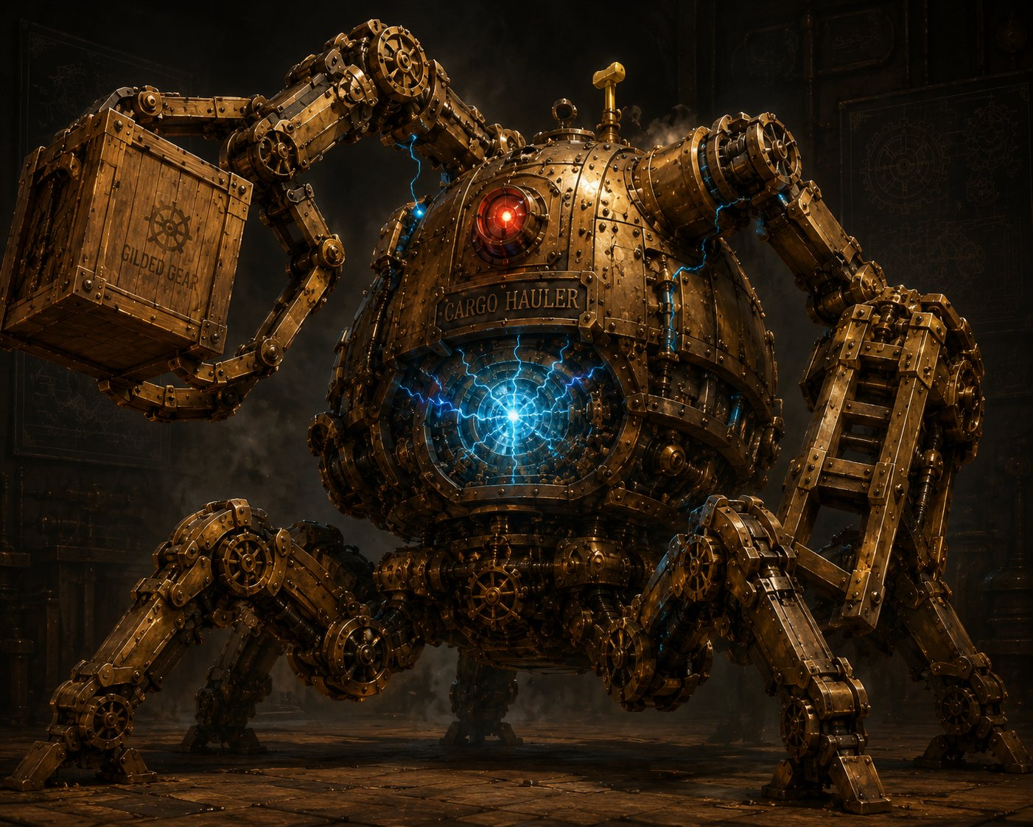  AC 16 HP 76 (8d10+32) Speed 30 ft  STR 19 DEX 8 CON 18 INT 3 WIS 8 CHA 5  Resist nonmagical B/P/S  VULNERABLE lightning (overloaded core — telegraph it!)  Imm. (cond) charmed, exhaustion, frightened, paralyzed, petrified, poisoned  Traits  Out-of-Reach Switch. Lever is 15 ft up on its back. Disable needs reaching that height (climb DC 13 / fly) + action + DC 15 Arcana or Sleight of Hand.  Actions  Multiattack. Two Forklift Slams, or one Slam + Hurl Crate.  Forklift Slam. +6 to hit, reach 10 ft. Hit: 13 (2d8+4) bludgeoning, DC 14 Str or knocked prone.  Hurl Crate. Ranged +6, 60 ft. Hit: 14 (3d6+4) bludgeoning.  Grab & Crush (Recharge 5–6). One creature within 10 ft, DC 14 Dex or grappled (escape DC 14), taking 10 (3d6) at the start of each of its turns until it escapes.
Tactics: The Hauler anchors the fight — it grabs the squishiest hero (Lilly or Ursa) and crushes while the servitors flank and spark. Bunch up and the death-sparks hurt. Smart parties exploit the Hauler’s lightning vulnerability and try to reach its switch. Let a hero drop to 0 if the dice say so — it makes the win feel earned.

